**PROJECT REPORT**

**ON**

**EMPLOYEE ATTRITION PROBLEM**

**BY**

**PAUL OYOM**

1. **INTRODUCTION**

The Employee attrition problem refers to the decrease of workforce or loss of employees for a number of reasons including job satisfaction, pay, age, sickness, retirement, death, and resignations. Employee attrition is major concern for all companies in different sectors and understanding it is paramount.

There are sure solutions to controlling the steady decline in workforce but we can decrease it by carrying out efficient strategies. This report provides an insight into how employee attrition can be controlled by considering a number of factors like satisfaction level, number of projects, average monthly hours, last evaluation, work accidents, salary and department among others.

1. **PROBLEM STATEMENT**

Company X is trying to control attrition. There are two sets of data which are “Existing employees” and Employees who have left”. Each employee has the following attributes:

1. Satisfaction level
2. Last evaluation
3. Number of projects
4. Average monthly hours
5. Time spent at the company
6. Whether they have had a work accident
7. Whether they have had a promotion in the last 5 years
8. Departments (column sales)
9. Salary
10. Whether the employee has left
11. **OBJECTIVE**

The objective of this study is to determine what type of employees are leaving and also determine which employees are prone to leave next.

1. **METHODOLOGY**

The Methodology is carried out in three stages:

* Univariant analysis: This involves analyzing the data from ‘Employees who left’ and also analyzing data from ‘Existing employees’ and visualizations to discover patterns.
* Bi/Multivariant analysis: This involves analyzing other attributes of data from ‘Employees who left’ and those from ‘Existing employees’ to find out correlations.
* Observations and Insights: The results from previous stages provides observations and recommendations.

1. **DATA ANALYSIS AND INTERPRETATION OF DATA**

The dataset is imported using the Python packages, read the excel file and parse each data from ‘existing employees’ and ‘employees who have left’

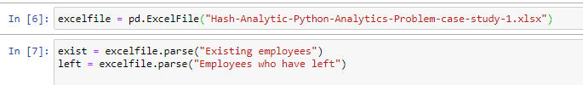

We use the head function, head() to view the first five records in each data. We use exist.head() to view to first five records in ‘Existing employees’

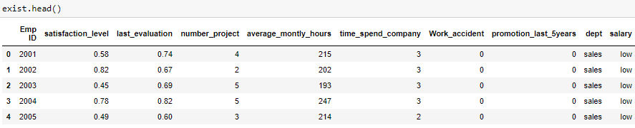

We then use left.head() to view to first five records in ‘Employees who have left’

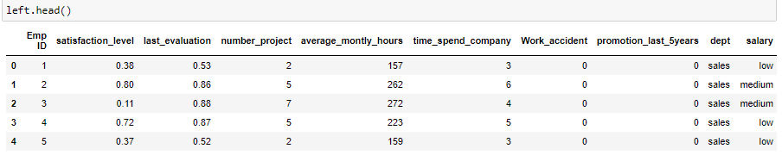

Next is data preprocessing where we prepare and analyze the data.

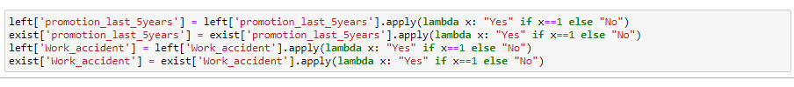

Univariant analysis of existing employees and employees who left.

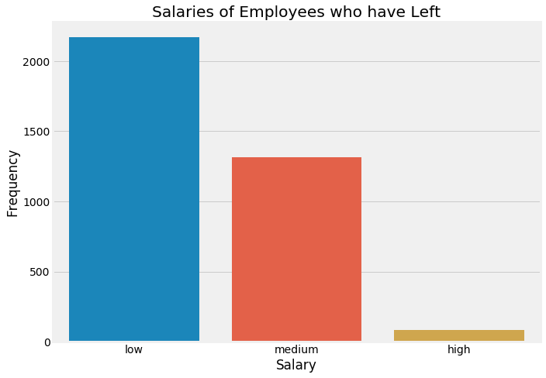

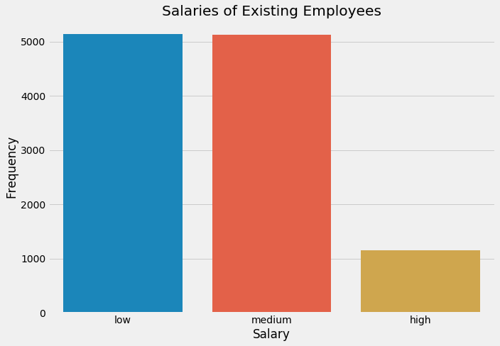

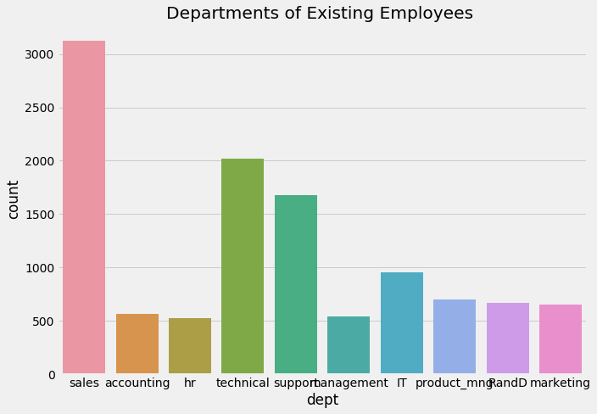

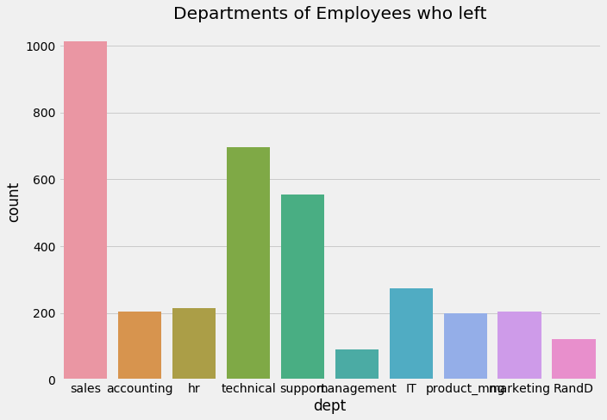

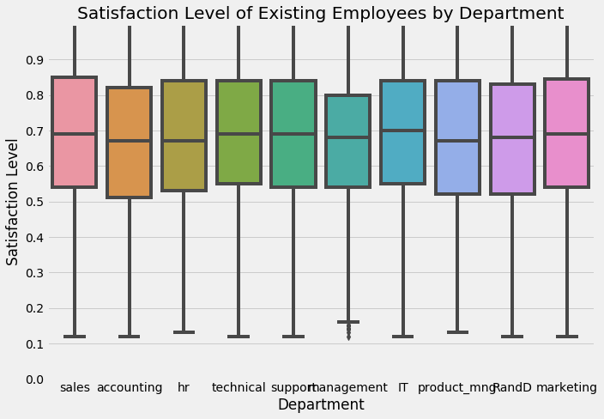

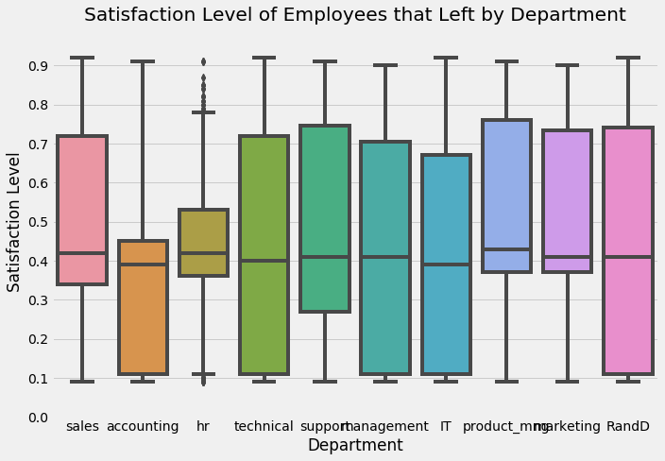

We can infer from these box plots that:

1. The median Satisfaction level of employees that left is between 40-50%and

2. The median Satisfaction level of employees existing is between 65-70%

We then carry out further analysis on the satisfaction level;

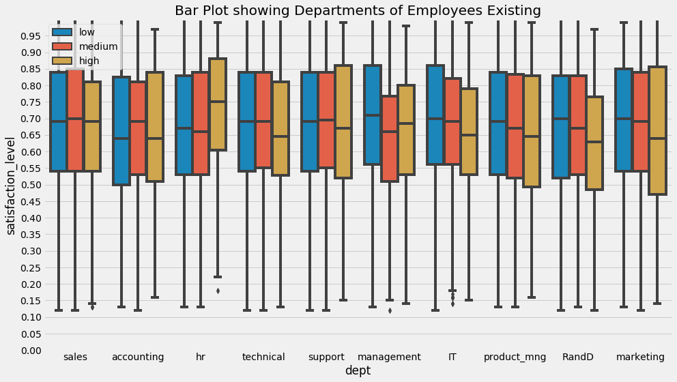

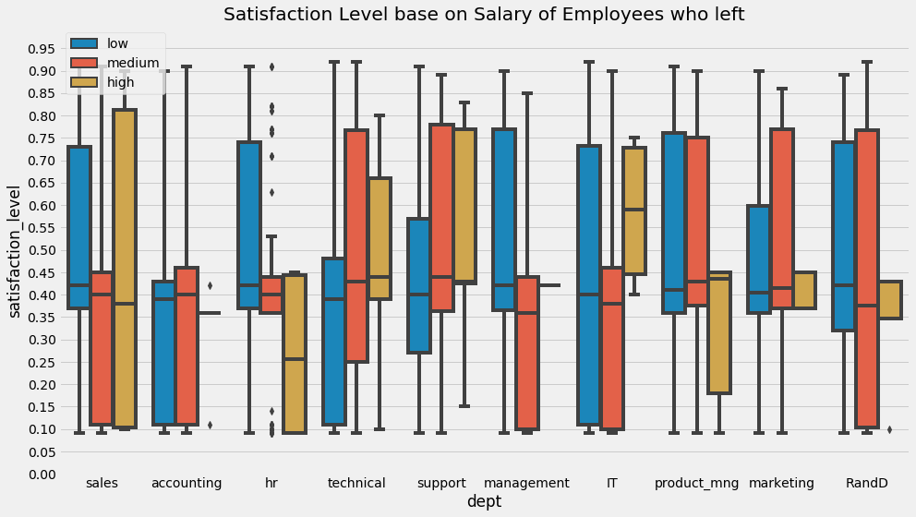

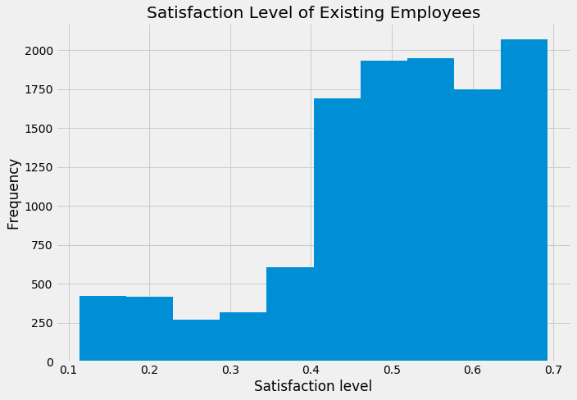

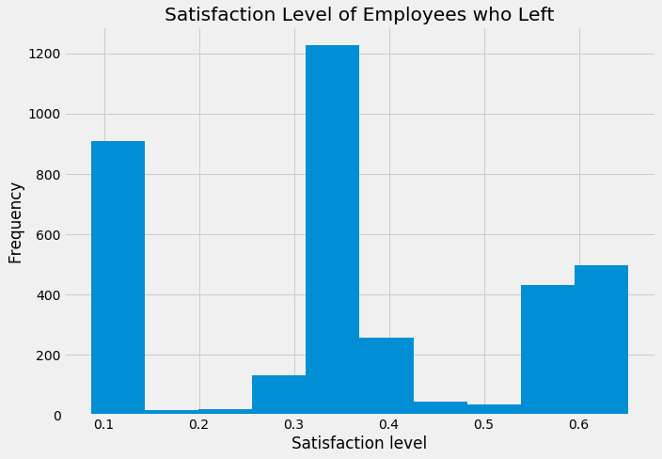

The satisfaction level of employees who left is relatively low.

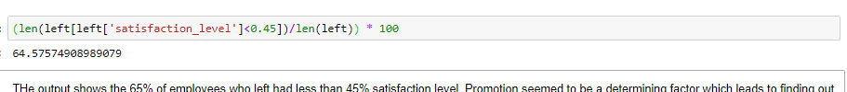

The output shows the 65% of employees who left had less than 45% satisfaction level. Promotion seemed to be a determining factor which leads to finding out the amount of employees who left that had less than 45%

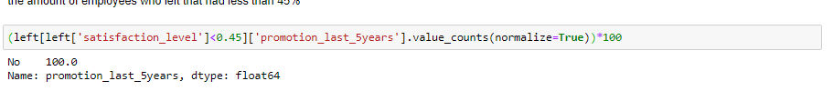

From the result displayed, about 100% of employees that left who had less than 45% satisfaction level were not promoted in the last 5 years which can described as a factor why they left. We then check for salary range.

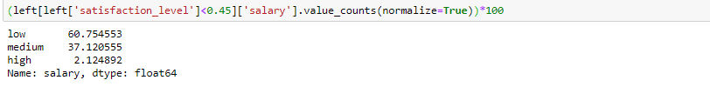

It shows that 61% of the employees were low income earners.

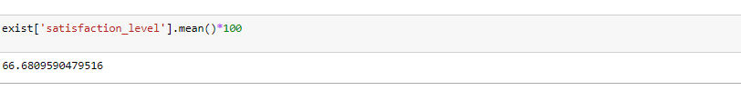

We see from the output that the average satisfaction level of the existing employees is around 70%.

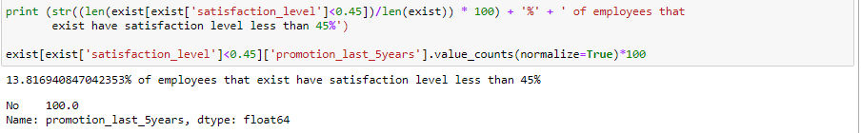

13% of existing employees had satisfaction level less than 45%

We then carry out the last evaluation of existing employees and those who left

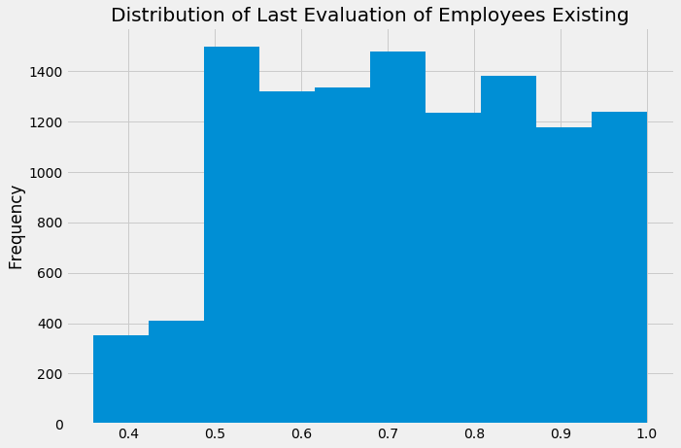

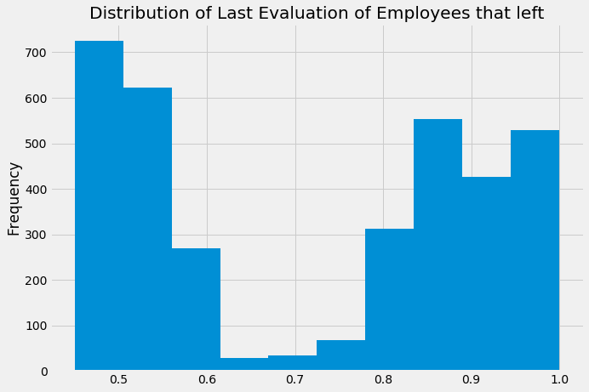

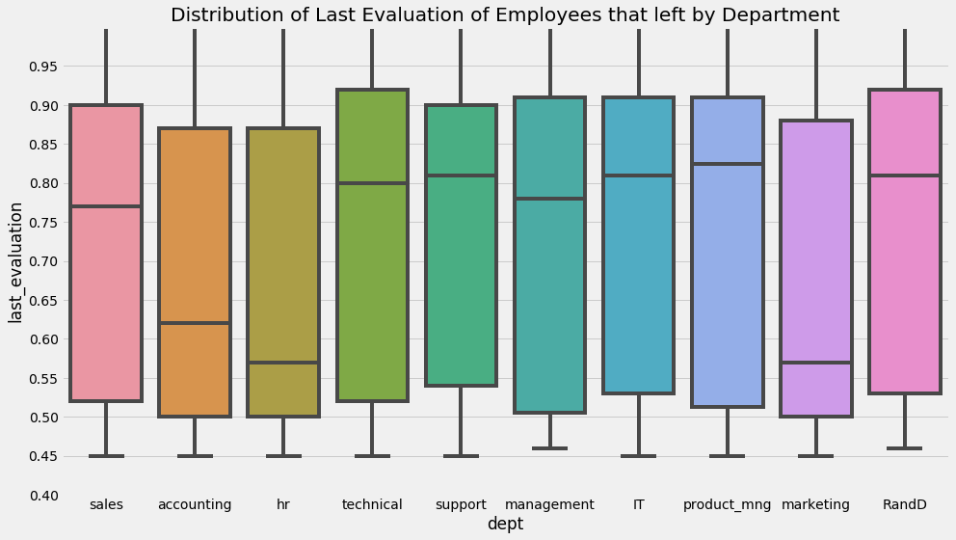

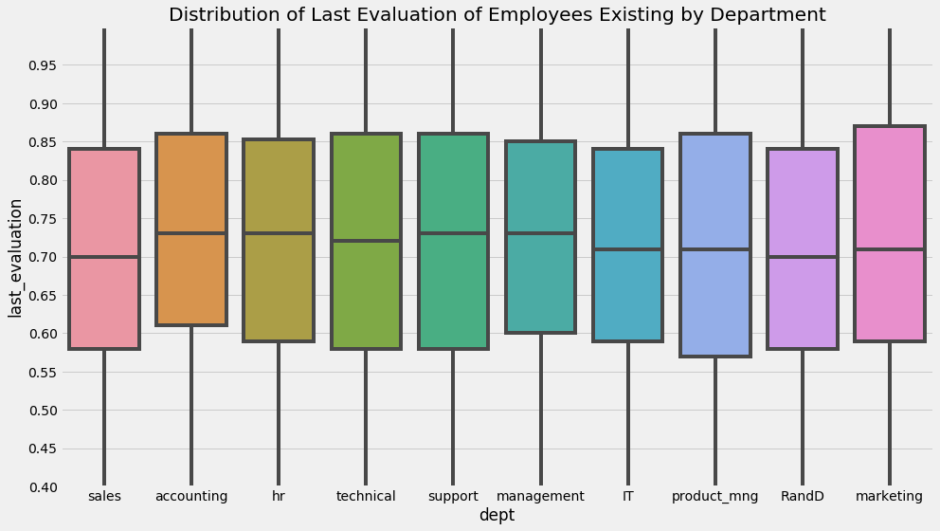

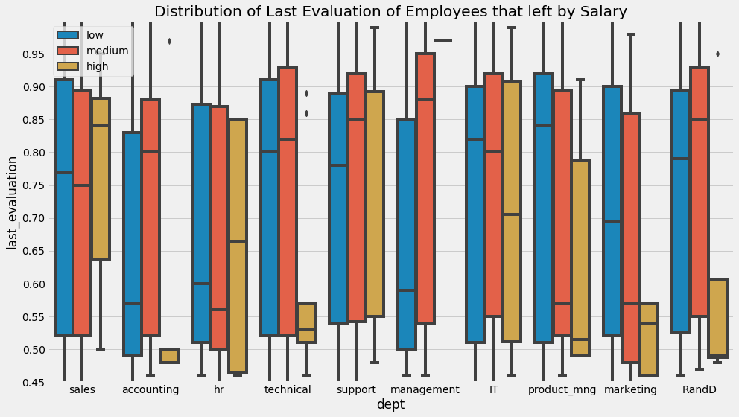

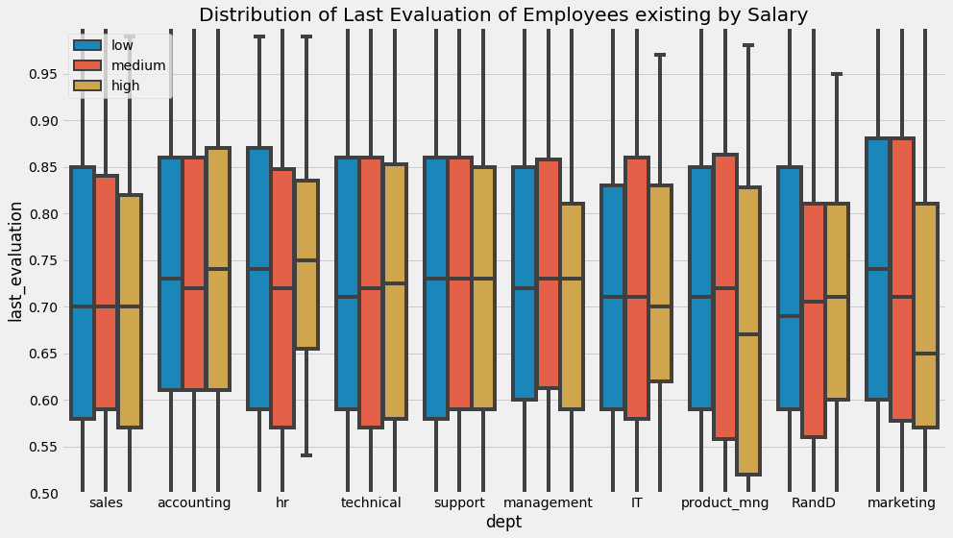

Moving on to stage 2 of our methodology, we carry out Bi/Multivariant analysis

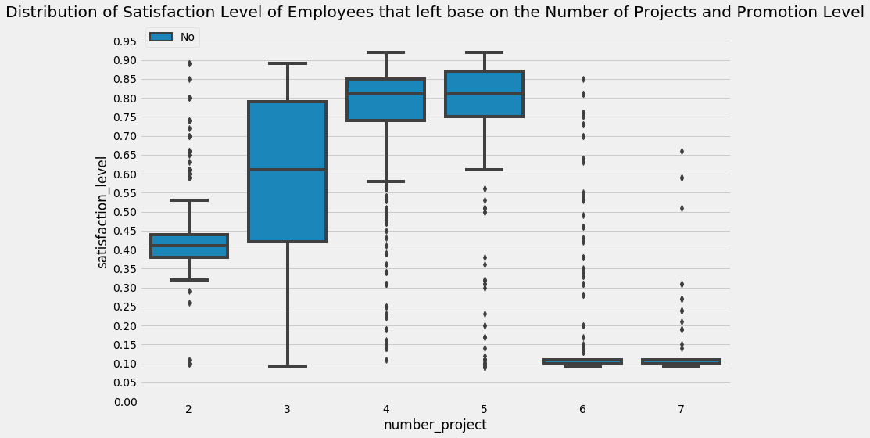

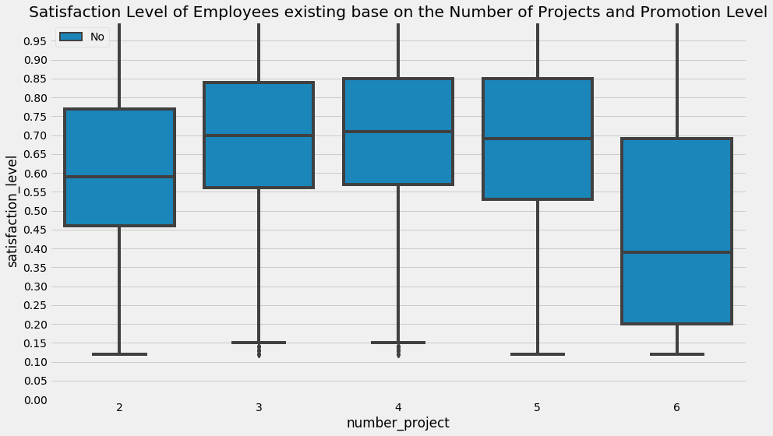

The output shows a good percentage of employees that left had low satisfaction level and large percentage of them had no promotion in the last 5 years. We then create a cluster from the database on salary range and analyze.

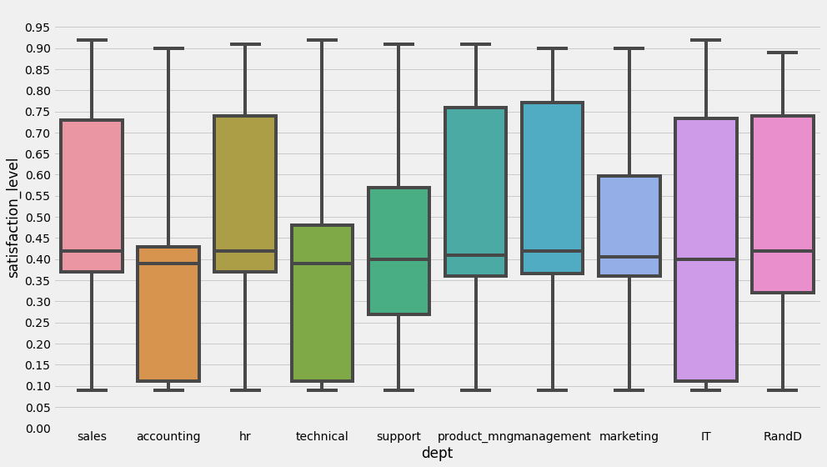

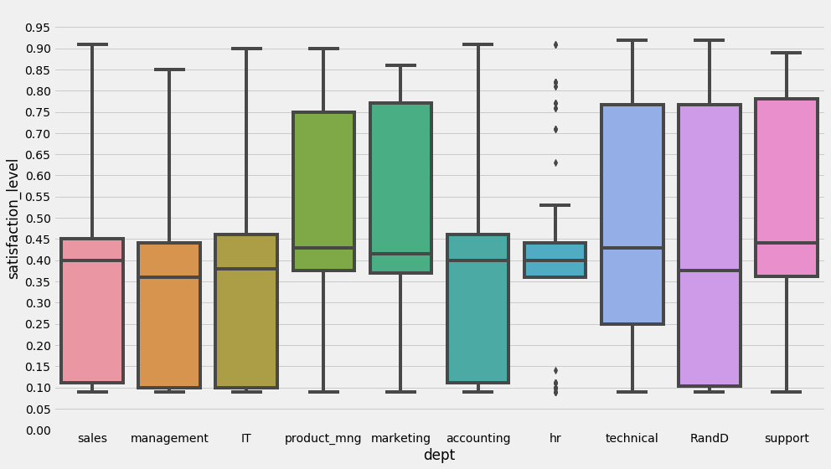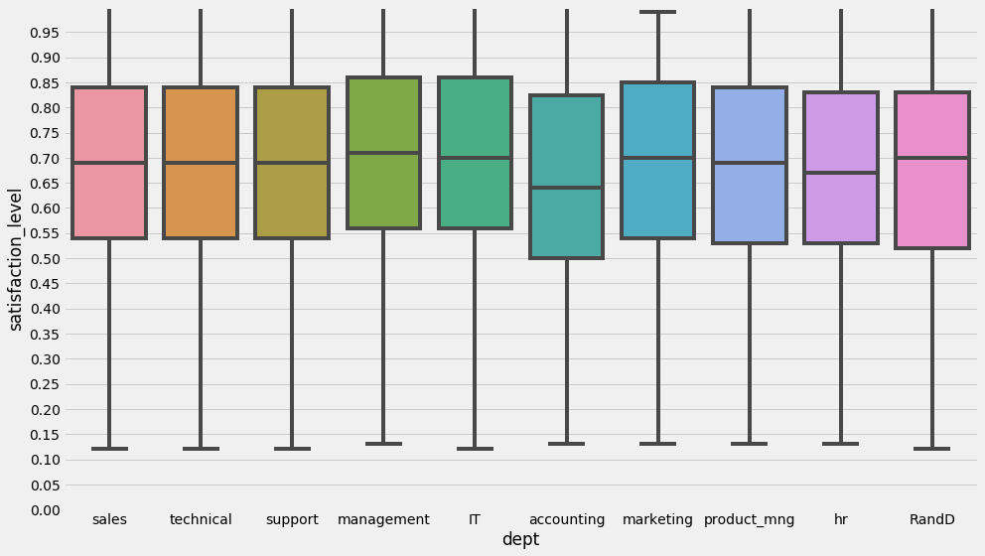

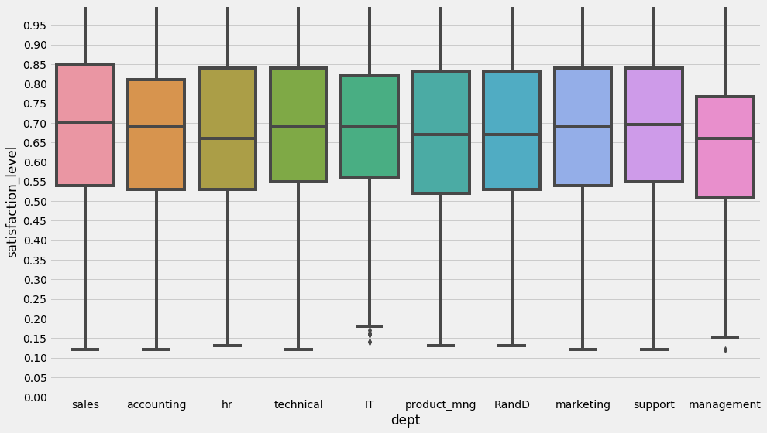

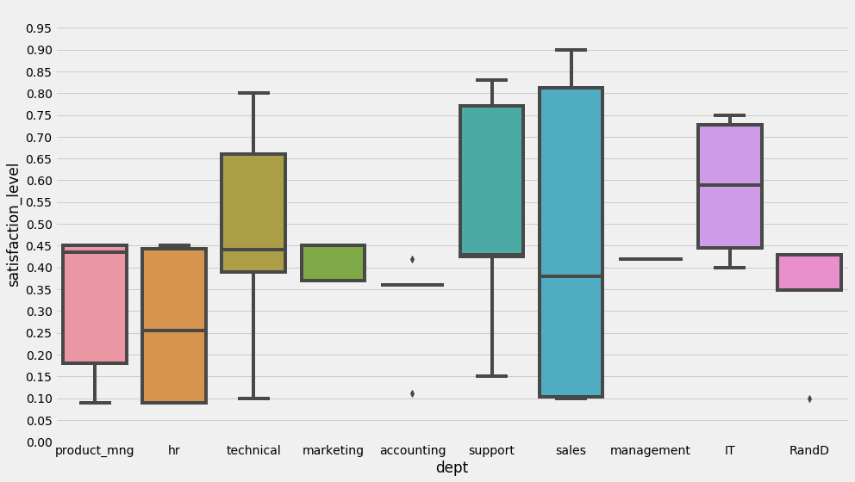

It can be deduced from the output that from the salary ranges for employees who left, the satisfaction level was less than 45% for the existing employees the satisfaction level was above 60%. This implies the satisfaction level is a key factor and it explains the type of employees who left those prone to leave.

We then analyze for satisfaction level based on accident.

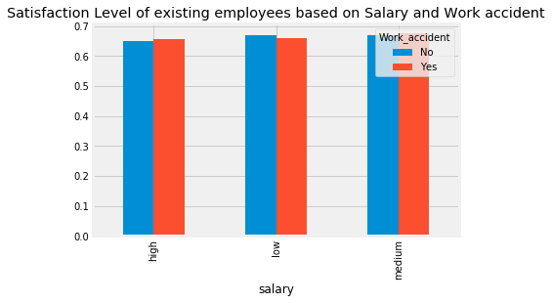

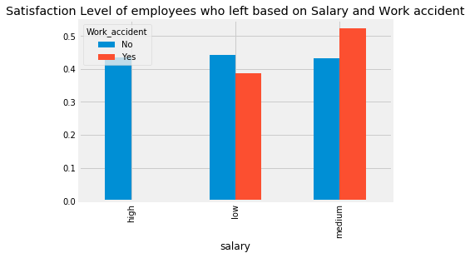

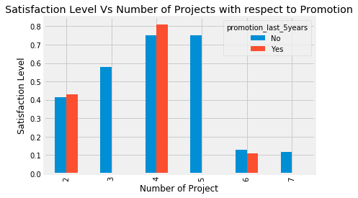

Satisfaction level of employees that left based on the number of projects and promotion

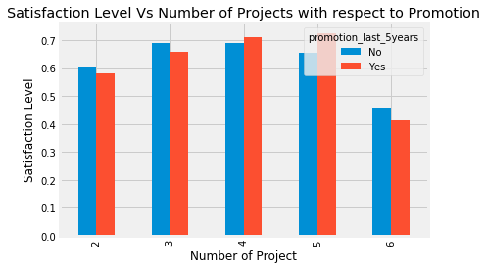

Satisfaction level of existing employees based on the number of projects and promotion

1. **FINDINGS AND CONCLUSION**

The mean satisfaction level of employees who that left was about 40% while for existing employees it was 70%. Further analysis revealed that 65% of employees that left had less than 45% satisfaction level**.** Looking further into this revealed that from the employees with 45% satisfaction level who had left, it was further discovered that 100**%** of them didn’t receive promotion in the last 5 years.

Comparing this with existing employees 13% of them had a satisfaction level less than 45% and about 100% of them had not been promoted within the last 5 years which made them more likely to leave.

To control the attrition, it is advisable to identify these employees and have them remunerated in the best possible way to increase their satisfaction level.

The salary structure of the employees who left as a result of work accident fell within the Low and Medium range and satisfaction level was around 50%. Similarly, the existing employees had their salary structure was distributed among low, medium and high range thereby improving the satisfaction level.

This should tell us that Company X maintained a good salary structure for those employees that had work accidents. Salary structure of the employees who left as a result of work accident fell within the Low and Medium range and satisfaction level was around 50%. Similarly, the existing employees had their salary structure was distributed among low, medium and high range thereby improving the satisfaction level.

This should tell us that Company X maintained a good salary structure for those employees that had work accident. A recommendation would be to allow the company maintain keep or increase the salary structure to increase satisfaction level.

Finally, the number of projects of employees who left increased greater than 4, it led to a decrease in their satisfaction level. A recommendation for this is to make sure the number of projects assigned to an employee do not overwhelm them to prevent a decrease in motivation and finding a reason to leave.